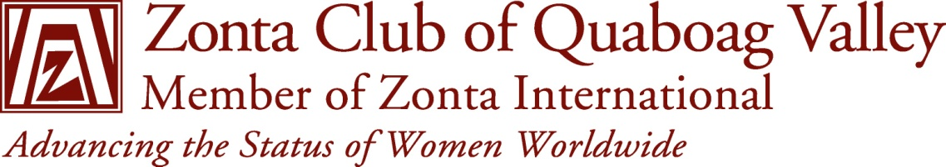
FOR IMMEDIATE RELEASE Please help us pass the word
January 17, 2014
For additional information contact Kristin M. Goold, 413 783-4376

APPLICATIONS BEING ACCEPTED
LUDLOW – Scholarship Chair, Kristin M. Goold, of Springfield, MA has announced that the Zonta Club of Quaboag Valley is accepting applications for two awards.
The Young Women in Public Affairs Award recognizes young women for their demonstrated leadership skills and commitment to public service. We are looking for women in the Quaboag Valley and surrounding towns who are high school juniors or seniors and have an active commitment to volunteerism, experience in local or student government, demonstrated leadership skills, and dedication to advancing the status of women throughout the world. The club offers an award of $500 to be used however the recipient chooses, to the most outstanding YWPA applicant. The application is available at the club’s site: www.zontaqv.org. The return date is March 15, 2014.
The Jane M. Klausman Women in Business Scholarship is open to women in Western MA enrolled in at least the second year of an undergraduate program through the final year of a Master’s program in business, leading to a business management career. The program is designed to encourage women to enter careers and to seek leadership positions in business-related fields in their communities and throughout the world. The club offers a $500 scholarship to the most outstanding Klausman applicant. The application is available at the club’s site: www.zontaqv.org. The return date is May 15, 2014,
For both leadership awards, the local winner’s application will then be submitted for competition at the Zonta District 1 level (New England states of the U.S. and the Atlantic Provinces of Canada). The District 1 winner goes on to compete internationally. District and International awards are funded by the Zonta International Foundation.
The Zonta of Quaboag Valley is part of Zonta International – an organization with over 1200 clubs in 65 countries and geographic areas. Local projects of the club include raising awareness on issues of domestic violence, homeless women veterans, trafficking of women and children, and suicide prevention in Western MA. Members include residents of Palmer, Ware, Wilbraham, Hampden, Ludlow, Chicopee, Springfield, Westhampton, Amherst, Belchertown, Westfield and Sturbridge. For additional information visit the club’s website at zontaqv.org or email: info@zontaqv.org

– 30 –

